**Protocol for CWD sampling on LTREB plots**

L Nave and N Van Dyke (8 May 2014)

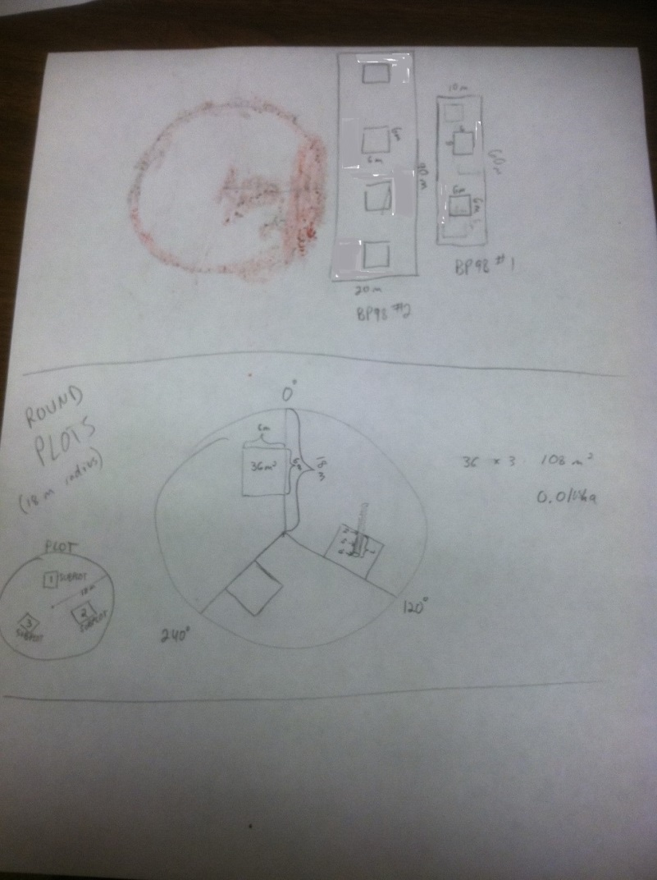Coarse woody debris (CWD) is sampled in 6m x 6m subplots in the various LTREB plots. See the photo below for diagrams of the location of these subplots within the LTREB permanent plots.

In the majority of LTREB plots, which are 0.1 ha circles, the 3 CWD subplots are located on azimuths of 0, 120, and 240 compass degrees. Be sure when establishing these subplots for the first time that each one is indicated by a brightly painted rebar stake ~50cm tall, and that this stake marks the closer, right-hand corner of the subplot (as viewed from the plot center). Use compass and strings of known length to establish precisely-sized, properly square subplots, as scaling up CWD measurements depends on installing these subplots with geometric accuracy. In the case of LTREB permanent plots that are not 0.1 ha circles (i.e., those in the 98 Burn Plot and the BS40E Forestry Plot), we sample CWD in whatever number of 6m x 6m subplots are needed to cover ~10% of the total plot area (i.e., 4 subplots in the 0.14 ha plot in the 98 burn, 2 subplots in the 0.06 ha plot in the 98 burn, and 3 subplots in the BS40E Forestry Plot). These subplots should be installed within their parent plots in a systematic fashion, avoiding edge effects (see photo above for examples from 98 Burn Plot).

Rules / Decision Criteria

1. Minimum diameter: we need to estimate the volume of all CWD of a diameter 5cm or greater. If a piece of CWD is mostly ≥5cm diameter but a portion of it is <5cm diameter, measure the extent of the piece that is ≥5cm diameter. In such case one of the endpoint diameters will be 5cm, and the other will be either the diameter of the piece at its other end, or where it exits the subplot. If a piece of CWD is ≥5cm diameter at both ends and at its midpoint, but portions of its length are <5cm diameter, measure it as one piece anyway (not sure if this will happen in the field but trying to anticipate).
2. Minimum length: the minimum length for tallying/measuring an individual piece of CWD is 0.2 m. This length applies to pieces contained entirely within the CWD subplot, as well as to pieces that extend outside the boundary of the CWD subplot (i.e., there must be ≥0.2 m of material within the subplot).
3. If a piece of CWD extends outside the boundary of the subplot, measure its endpoint diameter where the plot edge (defined by string boundary) intersects with the center axis of the piece of CWD.
4. Do not tally pieces of CWD that are so soft and rotten as to be completely colonized by moss/vegetation, or which no longer possess an approximately cylindric shape. These criteria typically travel as together, i.e., the most rotten pieces of CWD are flattened in shape, have become integral with the soil/O-horizon, and are colonized by vegetation.
5. Pine stumps: Some of the CWD in the subplots will be present as stumps or short snags, most often pine. If such stumps/snags are ≥1.37m tall, they qualify as standing dead and will be measured as part of tree inventory. If <1.37m tall, such a snag is CWD and should be measured with 3 diameters and a length (which is actually height). Note that quite often, a pine stump will have intact sapwood and a well-defined cylindric shape but will have a hollow or soft, vegetation-colonized heartwood. Use decay classes (detailed below) to describe these stumps.

Decay Classes

Decay classes are best assigned without over-thinking, because the descriptions below are very generalized and do not apply equally well to all species of wood. The thing to keep in mind when assigning decay classes is that Class 1 is recently downed material that is essentially still intact and Class 5 is rotten *almost* to the point that it is not worth tallying (see note 4 above). Note as well that the decay class is to be assigned to the extent of the piece of CWD that is within the subplot; portions of the piece may be more or less decayed so a judgment call is required to assign a single category to the whole piece.

Decay Class 1 - Recently downed material - tissue and bark intact throughout

Decay Class 2 - Sapwood beginning to decay but completely present- Bark beginning to crack

Decay Class 3 - Sapwood and bark mostly present-heartwood tissue intact

Decay Class 4 - Sapwood and bark mostly gone with heartwood beginning to decay

Decay Class 5 - Sapwood and bark gone-heartwood decay substantial-original shape spreading but still distinguishable from soil

*Pine Stump- Decay Class 1*- stump intact and possessing firm sapwood and heartwood

*Pine Stump- Decay Class 2*- Sapwood intact, half or more of the total stump height still has heartwood

*Pine Stump- Decay Class 3*- Sapwood intact, less than half of the total stump height is full of heartwood (which is likely very soft)

*Pine Stump- Decay Class 4*- stump starting to lose its shape, heartwood soft and pieces of sapwood starting to break off and fall to the ground around stump (“stump pile”)

Supplies

* (4) 6m lengths of brightly colored string for temporary CWD subplot boundaries
* Painted rebar (one piece for a permanent corner of each CWD subplot, 3 pieces to use as temporary corners for CWD subplots while measuring)
* A pre-made tag for the permanent corner post of each CWD subplot
* Caliper for measuring diameters of CWD pieces (~50cm max, graduated in 0.1cm)
* Measuring tape for measuring lengths of CWD pieces
* Chaining pin for measuring tape (doubles as a probe for testing CWD to assign decay classes)
* Compass
* Data sheets

Procedure

Stake out corners and join with strings to establish the boundaries of the CWD subplot. Check for proper size/geometry. Move systematically through the CWD subplot, locating and measuring each piece. In subplots with large amounts of material (~a dozen or more pieces) it may be helpful to have additional string to separate the 6m x 6m subplot into halves or quadrants (else it is easy to lose track of which pieces have been measured and which remain). For each piece of CWD/row on the data sheet, record the LTREB permanent plot ID, the CWD subplot ID, the 4-letter species code (e.g., POGR, ACRU, QURU, PIST), 3 diameter measurements (cm; 2 endpoints and a midpoint), length (m), and the decay class.